December 4th, 2021-
Join us in Coloma for a day full of events!!!

Starting the morning off bright and early:

1. Craft Fair- 9-3pm at The Anna Follet Community Center. Contact Brenda Walker at our village office for info. Lunch is also available!
2. Coloma Public Library will be hosting activities and things for the kids to participate in while you check out the crafts! Make your gingerbread house ahead of time with the library’s supplies.
3. Keep the fun going and check out the local businesses to hunt for COLOMA'S ELF! See Elf Hunt game for details. Stop in at participating locations for a chance to win prizes for completed stops.
4. Bloody Mary Bar from 10-3pm and Mashed Potato Bar from 11-3pm at The Coloma Hotel.
5. DIY Sign Workshop with Front Street Creations starting at 11 at The Coloma Hotel. See their facebook page for more details on sign up. Walk-ins are also welcome along with already made gifts!
6. Gingerbread House Building Contest Sponsored by Flyte's Family Farm- Gingerbread Houses will be located at Studio Z during the day for judging. Stop in to check them out! See Flyte's Facebook event for more Contest rules or contact Carrie at 715-228-2304. Gingerbread House drop off by 8:59am to qualify for judging. Specials at Studio Z throughout the day!
7. Floral Workshop at Sensational Stems at 3pm- contact them to sign up and more details! Pre-registration required for workshop. Other Vendors including Chocolates by Donna Lavore will be set-up for the day as well!
8. The Cabin Bar & Grill, Jenna's Redhill Cafe, The Rough Cut Saloon and Crystal’s Woodlake Supper Club all have lunch and/or dinner specials for the day as well. Crystal’s has a gift certificate special!
9. 5pm Lighted Christmas Parade: Line-up at 4:15pm. Contact Michaela at Sensational Stems if you would like to be in the Parade as there have been changes! (715) 782-9033
10. Free Pictures with Santa and Mrs. Claus in the gazebo behind the Coloma Hotel after the parade!! Pick up your picture printed from the Library later in the week to finish your library project. As always, photos published to the Facebook page as well.
11. Games, activities and Music out front of the Hotel following the parade and tree lighting.
12. Bring a gift for the Waushara Christmas project and get 5 free tickets for the basket drawing.
13. Basket drawing for more prizes.
14. Tasting at Coloma Liquors & a special at Coloma Resale.
15 10 minute massage by LouAnn available 10 am – 3 pm at Sensational Stems
16. DJ Music at the Rough Cut after the parade.
17. HOTDOGS, HOT CHOCOLATE, POPCORN AND MORE!
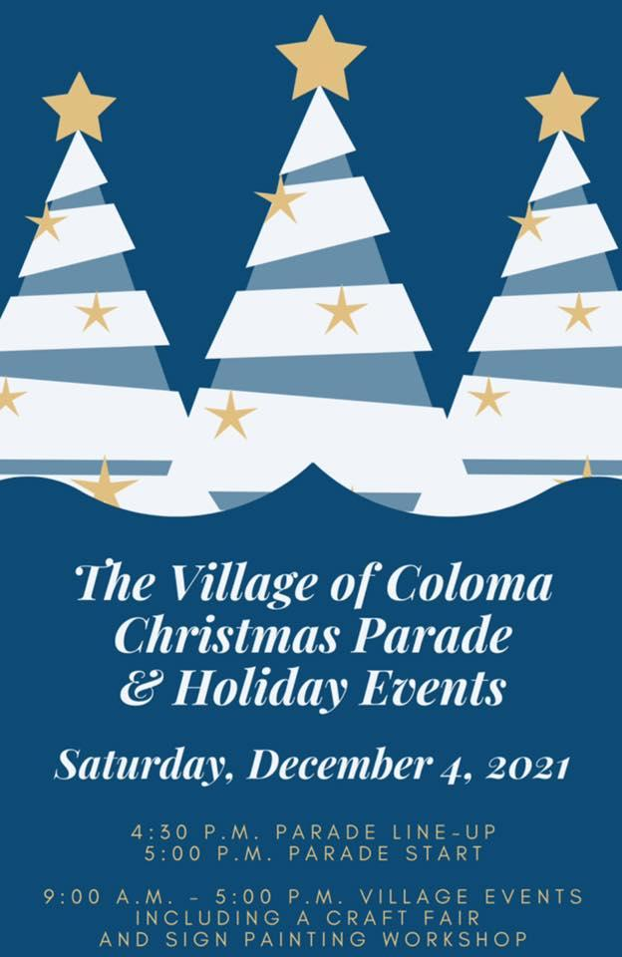
DON'T MISS OUT!!!! SO MUCH HAPPENING IN OUR LITTLE COMMUNITY THROUGHOUT THE DAY!

BROUGHT TO YOU BY THE COLOMA
BUSINESS ASSOCIATION!

