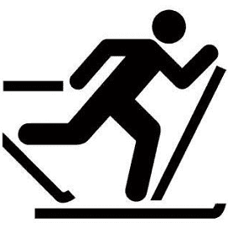
Saturday February 13
Coloma Glide & Ride
Coloma Community Park

Glide: Cross Country Ski Race
Registration: 9 am until time of race (10 am)
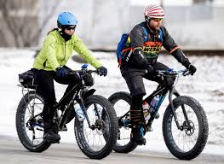
11:30: Children’s Ski Race on the Ball Diamond

Ride: Fat Tire Bike Race Noon

CONTACT INFORMATION
Phone: 715-572-1354 (Mike)
E-mail: annettefaith@hotmail.com
Website: colomapathfinders.com/events

Make checks payable to:
Coloma Pathfinders Snowmobile Club
Mail to: Susan Apps
PO Box 215
Coloma, WI 54930

COURSE DESCRIPTION
Cross Country Trail (2 laps) 13K
Fat Tire Bike Race (1 lap) 7K
Children’s Race (1K) Age 10 and under

AWARDS
- Medals to 1st, 2nd, 3rd (Male/Female)

Entry Fee

- $20/event
- $50/family
- $30/2 events
- $5/children

COURSE DESCRIPTION

Cross Country Trail (2 laps) 13K
Fat Tire Bike Race (1 lap) 7K
Children’s Race (1K) Age 10 and under

