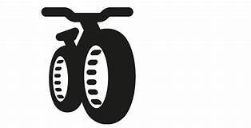
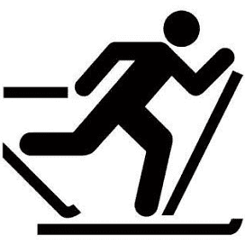
Saturday February 5
Coloma Glide & Ride
Coloma Community Park

Glide: Cross Country Ski Race
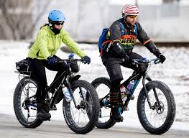
Registration: Starts at 8:30 am or on-line
9:30 am Race begins (Wave start)
13K Adult, 13K H.S,. 6.5K M.S,
11 and under Youth Division & Recreation Skate and Classic Divisions

Ride: 13K Fat Tire Bike Race after Ski Race
(approx. 11:30 am)

CONTACT INFORMATION
Phone: 715-572-1354 (Mike)
E-mail: annettefaith@hotmail.com
Website: colomapathfinders.com/events

Make checks payable to:
Coloma Pathfinders Snowmobile Club
Mail to: Susan Apps
PO Box 215
Coloma, WI 54930

COURSE DESCRIPTION
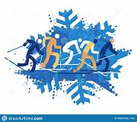
13K Cross Country Trail (2 laps)
13K Fat Tire Bike Race (2 laps)
6.5K Middle School and Youth (1 lap)

AWARDS
- Medals to 1st, 2nd, 3rd (Male/Female)

Entry Fee

- $20/event, adult
- $30/2 events
- $10 High or Middle School
- $5/youth

- $50/family for 1 event
- $80/Family for 2 events

